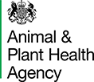 | Important Notice: Avian Influenza (Bird Flu) Case Debach | 
Attention Resident:
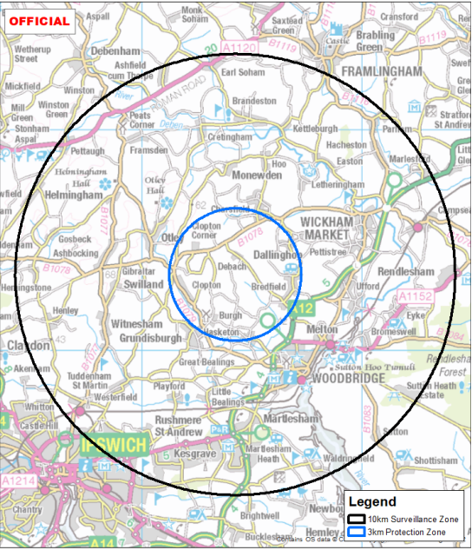

Highly Pathogenic Avian Influenza has been confirmed at premises in Debach near to Woodbridge in Suffolk and the Government has declared:


3km radius Protection Zones
10km radius Surveillance Zones
Scan this QR code to access the full declaration that imposes these zones and the controls they impose.
The risk to public health from the virus is very low, however it is important that people don’t pick up sick or dead birds.

APHA staff will contact registered poultry/captive bird keepers within the Protection Zone as (shown by the blue circle) to gather information that will help veterinary staff assess the risk of avian influenza spread. APHA veterinary staff may need to carry out an inspection of your birds to assess their health.

Please be reassured there is no automatic culling policy for avian influenza outbreaks. Birds will only be culled if Avian Influenza is confirmed in a flock following laboratory testing of samples, or if a veterinary risk assessment indicates any significant links to an infected premises.

Compulsory registration of poultry and captive birds with APHA has been required since 1st October 2024.

If you keep poultry or captive birds and have not registered them, you must do so via an online form at: www.gov.uk/guidance/register-as-a-keeper-of-less-than-50-poultry-or-other-captive-birds

Poultry keepers can also e-mail customer.registration@apha.gov.uk or phone: 03000 200 301 if more support is required

Disease Control Measures
If you have poultry or other birds at your premises, you must adhere to the conditions and movement
restrictions within the Protection Zone. Heightened biosecurity measures have been put in place to
protect your birds from disease and prevent its spread.

All poultry and captive birds must be housed within the 3 km Protection Zone and licences are required for movements to and from premises in the whole 10km Surveillance zone. Further information on the current avian influenza restrictions and controls put in place to control this outbreak can be found on the government website https://www.gov.uk/government/news/bird-flu-avian-influenza-latest-situation-in-england

Signs of Avian Influenza
If your birds become ill, consult your vet immediately. Avian Influenza spreads through direct contact or contaminated fluids and faeces. Symptoms in poultry include:

- Swollen head and blue discolouration of the neck and throat
- Loss of appetite and diarrhoea
- Respiratory distress (gaping beak, coughing, sneezing, gurgling, rattling)
- Reduced egg production and increased mortality

By law, if you or any suspicion of disease must be immediately reported to APHA by telephoning
03000 200 301.

Wild Birds
No action is required for wild birds, however, you can assist by reporting dead wild waterfowl (swans, geese, ducks) or other wild birds (gulls, birds of prey) to the Defra online at https://www.gov.uk/guidance/report-dead-wild-birds or call the helpline on 03459 335577.

